Session 2025-2026(EVEN)

Vision: Dream of where you want. | Mission: Means to achieve Vision

Program Educational Objectives of the program (PEO): (broad statements that describe the professional and career accomplishments)
PEO1 | Preparation | P: Preparation | Pep-CL abbreviation  pronounce as Pep-si-lL easy to recall
PEO2 | Core Competence | E: Environment (Learning Environment)
PEO3 | Breadth | P: Professionalism
PEO4 | Professionalism | C: Core Competence
PEO5 | Learning Environment | L: Breadth (Learning in diverse areas)

Program Outcomes (PO): (statements that describe what a student should be able to do and know by the end of a program)
Keywords of POs:
Engineering knowledge, Problem analysis, Design/development of solutions, Conduct Investigations of Complex Problems, Engineering Tool Usage, The Engineer and The World, Ethics, Individual and Collaborative Team work, Communication, Project Management and Finance, Life-Long Learning

PSO Keywords: Cutting edge technologies, Research

“I am an engineer, and I know how to apply engineering knowledge to investigate, analyse and design solutions to complex problems using tools for entire world following all ethics in a collaborative way with proper management skills throughout my life.” to contribute to the development of cutting-edge technologies and Research.

Integrity: I will adhere to the Laboratory Code of Conduct and ethics in its entirety.

Name and Signature of Student and Date
(Signature and Date in Handwritten)

Session | 2024-25 (EVEN) |  | Course Name | Java Full Stack Development Lab
Semester | 4 |  | Course Code | 23ADS1407
Roll No | 129 |  | Name of Student | Vidhi Chavhan
Practical Number |  | Practical 7
Course Outcome
Aim |  | WAP to demonstrate exception handling in java
Problem Definition |  | Develop a Java program to demonstrate exception handling by performing basic arithmetic operations. The program should accept user input and handle possible runtime errors such as division by zero and invalid input using appropriate try-catch blocks. The goal is to ensure the program runs smoothly without crashing and displays meaningful error messages.
Theory  (100 words) |  | - Exception handling in Java is used to manage runtime errors and maintain normal program flow.  - An exception is an unwanted event that disrupts execution.  - Java provides keywords like try, catch, finally, throw, and throws to handle exceptions.  - The try block contains code that may cause an exception.  - The catch block handles the exception and prevents program termination.  - The finally block executes regardless of exception occurrence.  - Common exceptions include ArithmeticException, NullPointerException, and InputMismatchException.  - Proper exception handling improves program reliability and user experience.  - It helps in debugging and ensures graceful handling of unexpected situations.
Procedure and Execution  (100 Words) |  | Procedure:  - Start the program and import required packages (java.util.Scanner).  - Create a class and main method.  - Declare variables for user input.  - Use Scanner to accept input from the user.  - Write code for an operation (e.g., division).  - Place risky code inside the try block.  - Add catch blocks to handle exceptions.  - Use finally block to display completion message.  Execution:  - Compile the program using javac command.  - Run the program using java command.  - Enter input values when prompted.  - If an error occurs, it is handled and message is displayed.
Code:
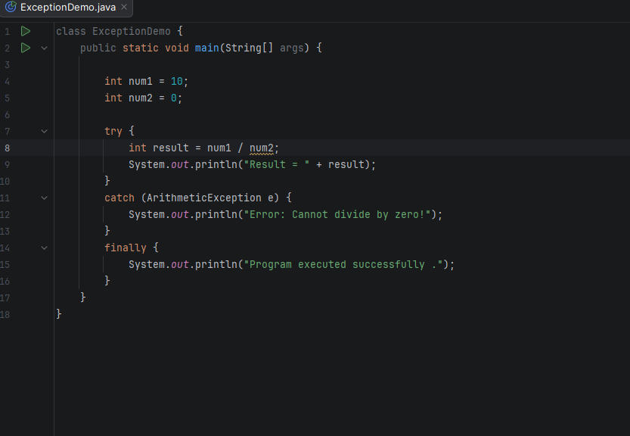
Output:
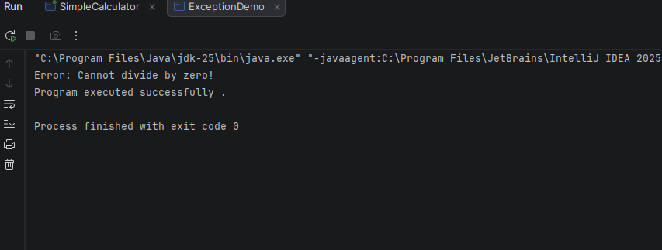

Output Analysis |  | - When valid input is entered, the program performs the operation and displays the correct result.  - If the user enters zero as a divisor, an ArithmeticException occurs and is handled by the catch block.  - If invalid data (like text instead of numbers) is entered, an InputMismatchException is triggered.  - The program does not crash due to proper exception handling.  - Error messages are displayed to inform the user about the issue.  - The finally block executes every time, showing program completion.  - This demonstrates that exception handling ensures smooth and reliable program execution.
Link of student Github profile where lab assignment has been uploaded |  | https://github.com/vidhichavhan18-cell/Java-Installation
Conclusion |  | Exception handling helps in managing runtime errors effectively without stopping program execution.  It improves the reliability and user-friendliness of Java programs.  Thus, proper use of try-catch blocks ensures smooth and error-free execution.
Plag Report (Similarity index < 12%) |  | 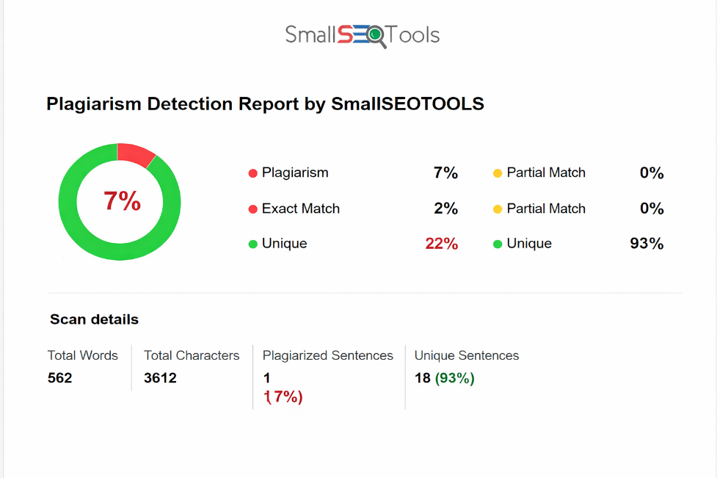
Date |  | 24.03.2026

Observation copy screenshot

